Notebook 5:

HTML Submit Form Data

|  |
| --- |
| <form action=”https://google.com”> |

* This form Action defines the absolute URL that your data is sent to

|  |
| --- |
| <form action=”https://google.com” method=”get”> |

* The get method is used by the browser to ask for a given resource

|  |
| --- |
| <form action=”https://google.com” method=”post”> |

* The post method is the method that the browser uses to talk to the server when asking for a response, that takes the data provided in the body into account

|  |
| --- |
| <input type="text"> |

* <input type= “text”> defines a single line text input field

|  |
| --- |
| <input type="submit"> |

* <input type=”submit”> creates a submit button that the site will use to send all of the needed information back to the server console.

|  |
| --- |
| <input value=" "> |

* The initial value of that certain section of code, otherwise known as the initial value of the control.

|  |
| --- |
| <input name="Yes"> |

* This assigns a name to the input field so it will become easier to find the data once it is all sent to the console, and it is not a big mess

|  |
| --- |
| <label for="name"> |

* Each input field must have a NAME attribute to be submitted

|  |
| --- |
| <cols> |

* The COL tag specifies column properties for each column within a <colgroup> element.

|  |
| --- |
| <textarea> |

* The TEXTAREA tag defines a multi-line text input control

|  |
| --- |
| <textarea rows="4"> |

* The rows attribute specifies the visible height of a text area, in lines/rows.

Here’s an example of some code

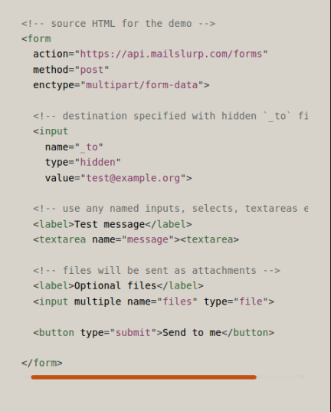

* The code snippet shown above gives examples of some of the elements touched on in this notebook, but there is also some that were not explained, such as form enctype, so here is some information on that.

|  |
| --- |
| <form enctype=”form-data”> |

* This explains where the form data is going to be submitted to once the form is completed. The “form-data” is a placeholder for the path for the JSON or text file, or whatever other file you are using, in which you are planning on storing the form data.